**Instructions Manual**

**About the DBMS**

This user manual contains information about a relational database management system created from scratch using C++. This database management system works with standard SQL.

**System Overview**

This database management system is able to do the following tasks:

1. Open database
2. Create database
3. Drop database
4. Create table
5. Drop table
6. Update table
7. Select from
8. Delete from
9. Insert into
10. List databases
11. List tables
12. Table info
13. Schema info

**Getting Help**

In order to get a list of all commands and their functionality, type: Image

Once you hit enter, you should see the following commands with detailed descriptions of each: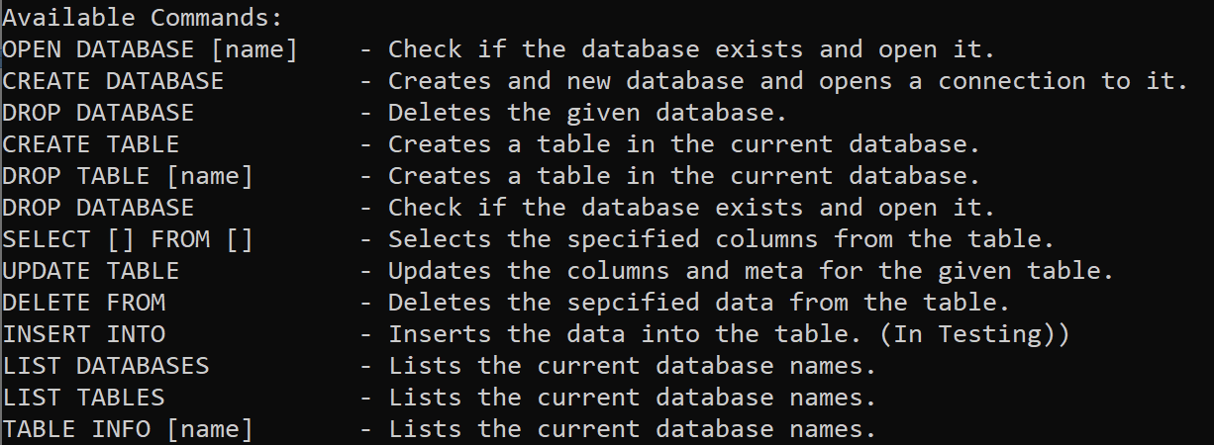

**To load a SQL file:**

You can load a SQL file into the database management system. To load a SQL file, please use the following instructions:Image

If the command is input properly, you should see this on the terminal:

Image

If a filename does not exist, the DBMS will create a new SQL file with the name input and load the newly created file.

**To create a database:**Image

If the database is successfully created, the DBMS will take you to the newly created database and you will see:

Image

**To open a database**:

To open a database, use the following command: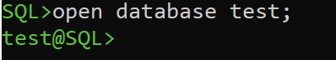

**To drop a database:**

Please use the following command:Image

If the database is successfully deleted, you will see the following in the DBMS: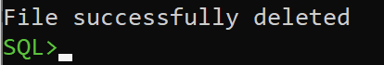

If a database does not exist, or you use the wrong database name, you will get the following message:

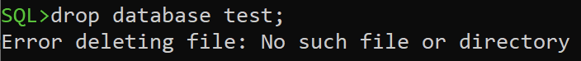

Note: Be careful with Capitalization as the database names are case sensitive.

**To create a table:**

You can use either VARCHAR or INT for column types. To create a table, use the following command:

ImageImage

**To select table values:**

To select table values, you can use the following commands:

You can use * to select all table columns:

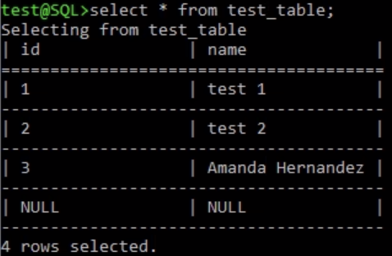

You are also able to select only 1 column:

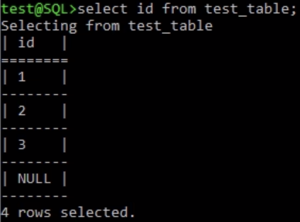

You can also select multiple columns separated by a comma. Note: selection can be in any order you like:

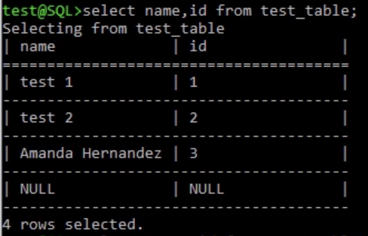

**To delete from:**

Please use the following command:



**To insert values into a table:**

To insert values into an existing table, please use the following command:

ImageImage

Note: Please note that you need to be careful with the capitalization of the table name, and column names in order for the DBMS to recognize the names.

It is also important to note that you **cannot** do the following:

insert into Customers (CustomerName, Country) values (‘John’);

Moreover, the following command is allowed but in this case, Country will be automatically set as NULL;

insert into Customers (CustomerName) values (‘John’);

**To list all existing databases:**

You can use the following command, in which case you will be a message with all the databases.

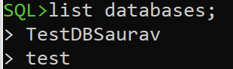

**To list all existing tables:**

You can use the following command, in which case you will be a message with all the table names within a database.

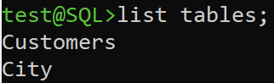

**To drop a table:**

You can drop a table with the following command:

Image

Once the table is dropped, you can use the list tables command to ensure whether the table was dropped:

Image

Once the DBMS is up and running, you can use the following list of commands to open, modify, and delete databases and tables.

**To update a table:**

You can update a table by using the following command:



**To get table information:**

To get table information, you can use the following command. This will print the table names, column names, and the number of rows in that table.

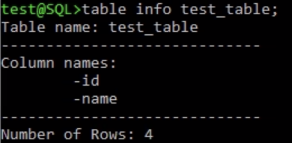

**To get database information:**

To get database information, please use the following command:

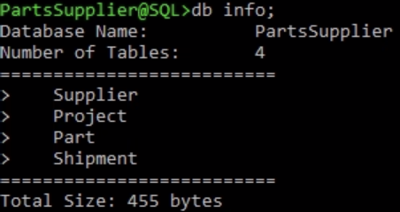

**Trouble Shooting/Error Messages**

To avoid running into errors:

1. It is important to note that all commands should end with a semi-colon. Without one, the system is not going to be able to detect the commands input.

If a semi-colon is not used, you will see the following message on the terminal:

Image

1. Most commands are not case-sensitive. Tables, Values, and Database Names need to

be cased.

For example;

(1) delete Customers where ‘Country’ == ‘Sweden’; will work because the table name

Customers is cased. Column names such as Country is also cased.

(2) If the command was input as:

delete customers where ‘Country’ == ‘Sweden’;

The system will not be able to find a table name ‘customers’ because lower-cased

‘customers’ doesn’t exist.

(3) If the command was input as:

delete Customers where ‘country’ == ‘Sweden’;

The system will not be able to find a column ‘country’ in the table name Customers

because lower-cased column ‘country’ doesn’t exist.

(4) If the command was input as:

delete Customers where ‘Country’ == ‘sweden’;

The system will be able to find both table name and column but the System won’t be the value contained in the column.

1. Proper spacing is also important for this database management system.

For example;

delete Customers where ‘Country’==‘sweden’; will not work as there is no spacing on

either side of the ==.